1. Screen shot of EER model

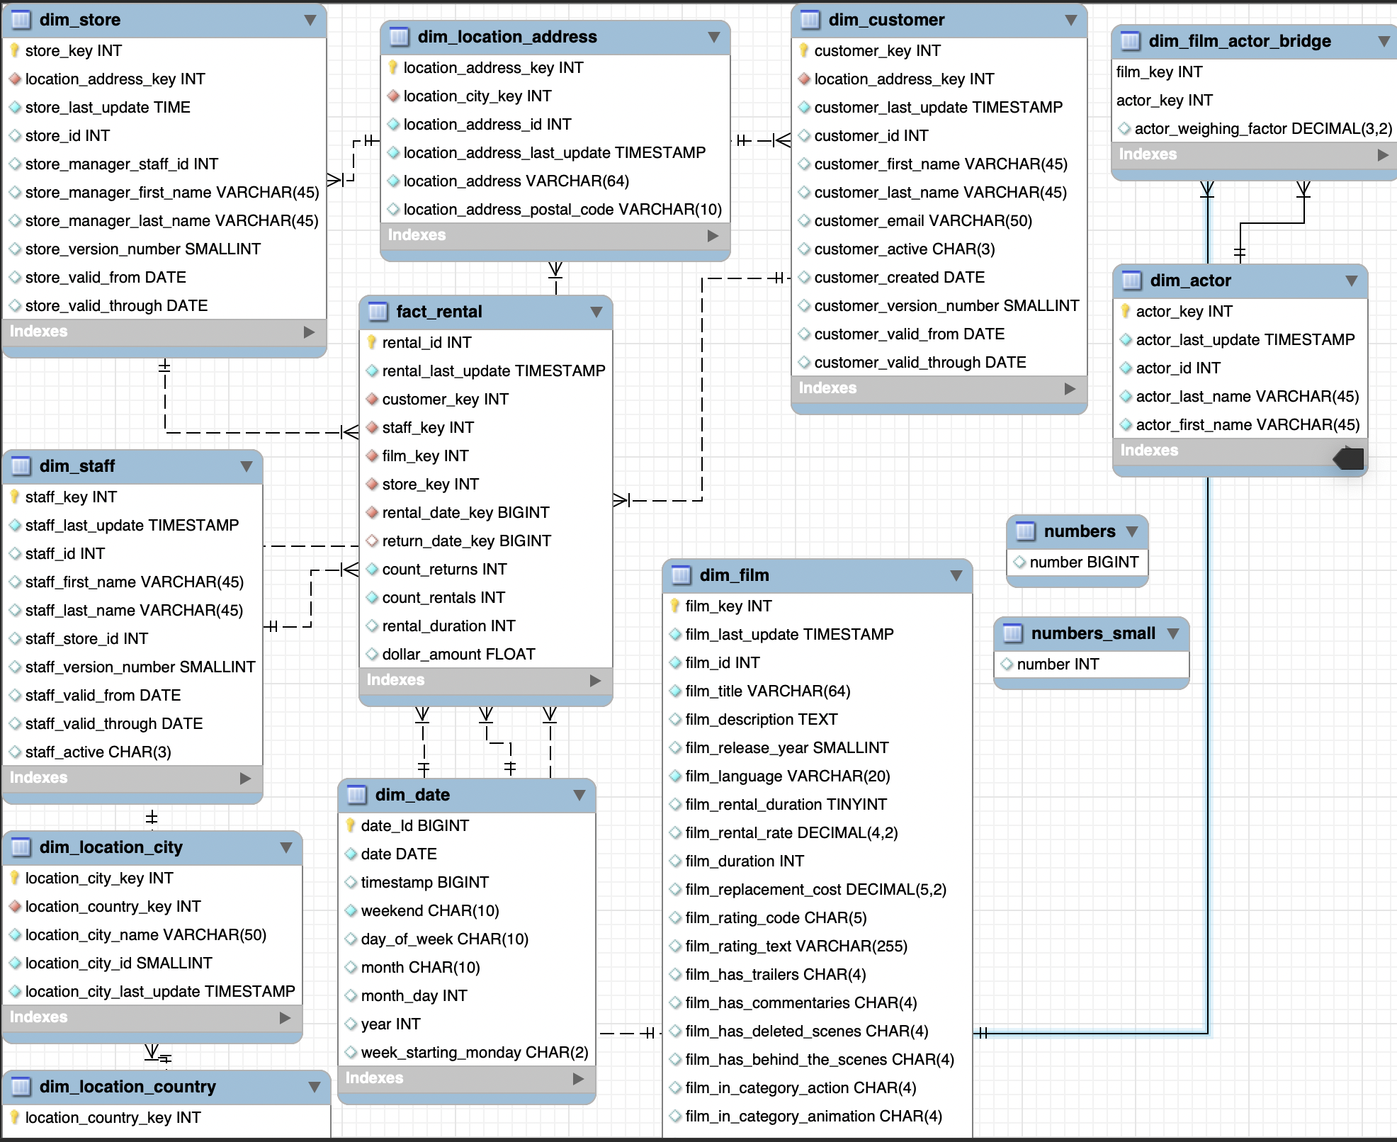

1. DDL For fact_rental table

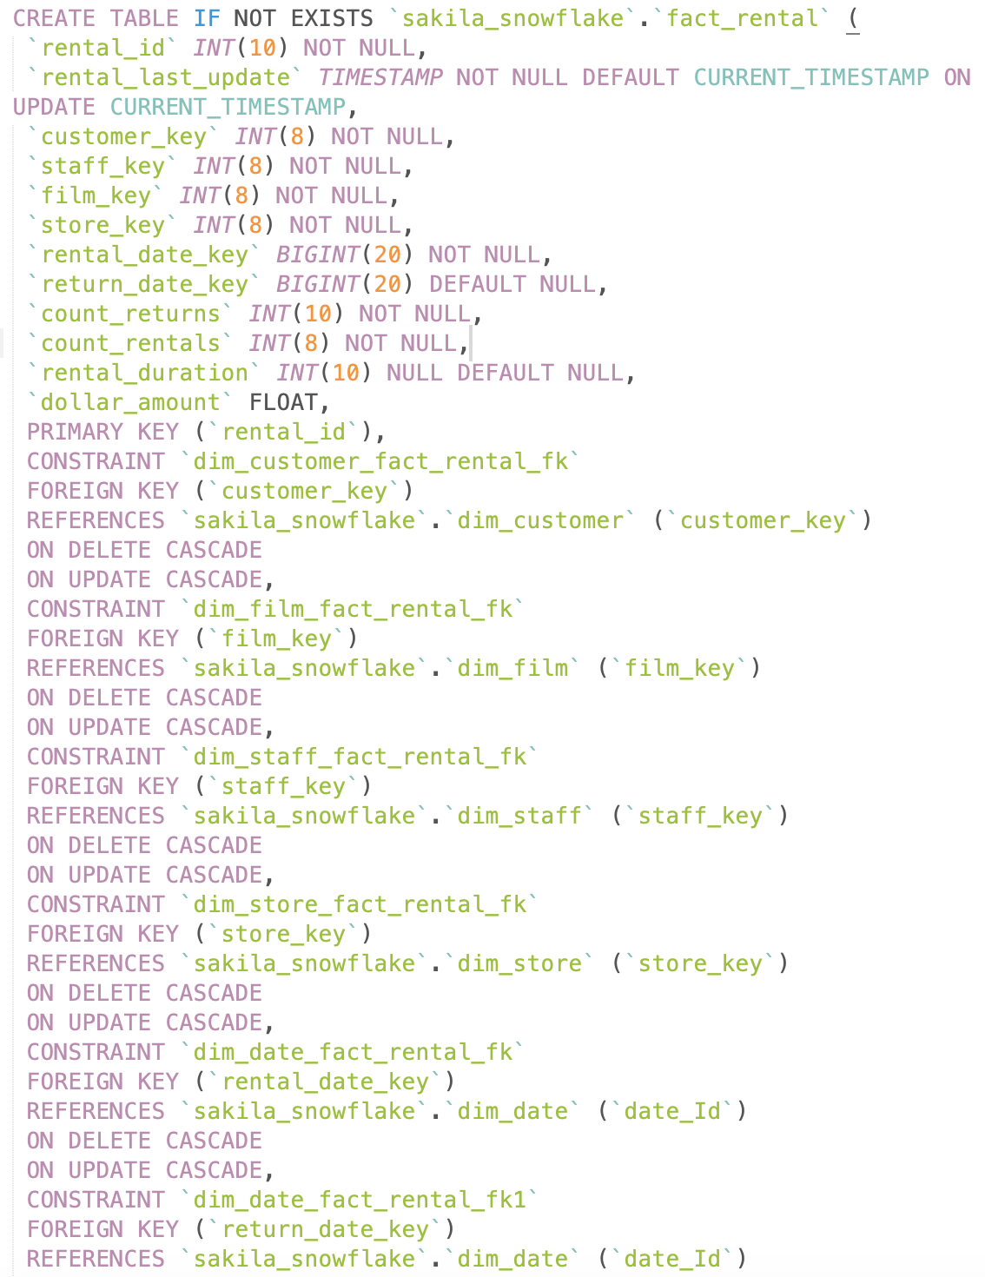

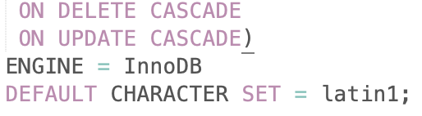

1. DML for fact_rental table

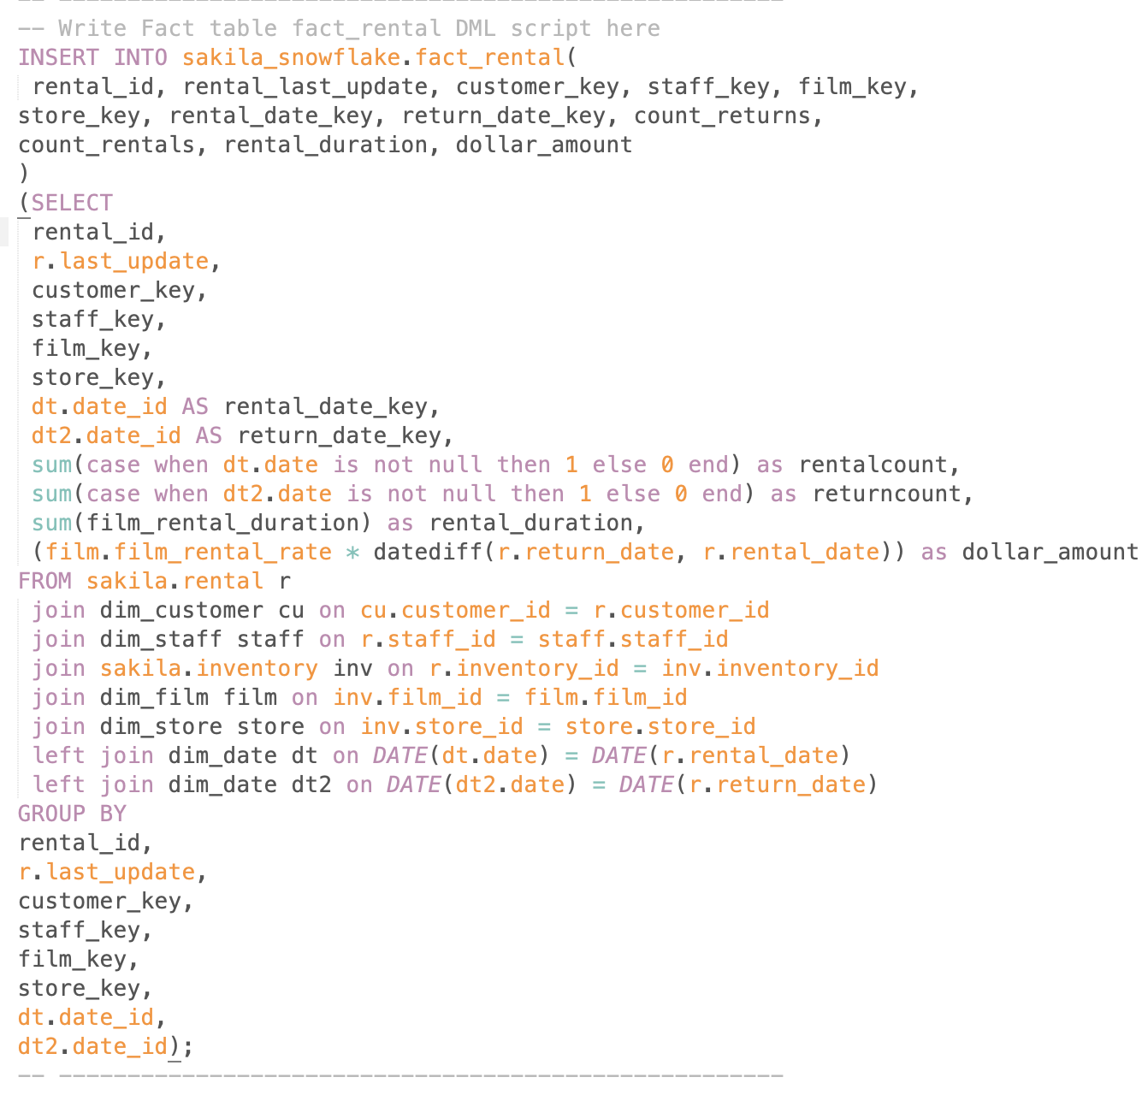

1. Final fact_rental table

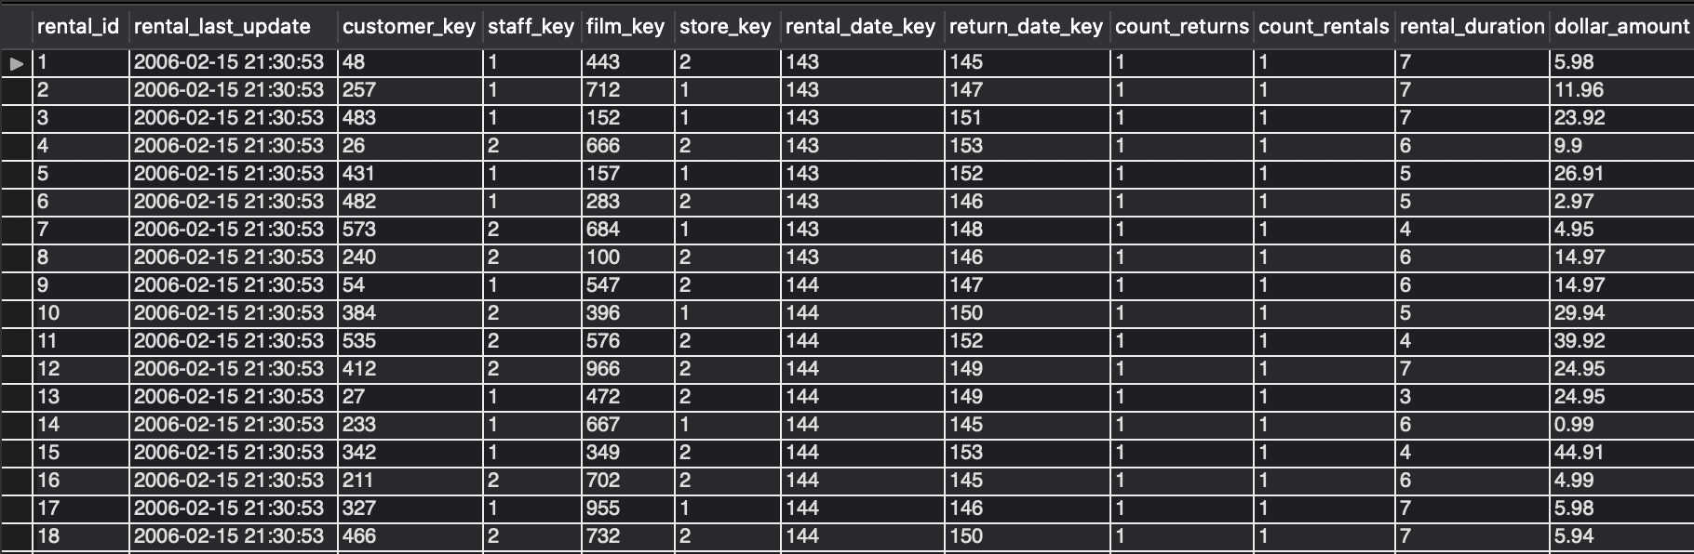

1. Assumption: Dollar amount is calculated by the number of date between return date and rental date times the rental rate from the film table
2. Improvement:
   1. the “film_in_category_scifi” returns null when reporting visualization
   2. the “film_in_category_xx” should be categorized to one specific column for the convenience. I also grouped it to film_category in the tableau visualization